|  |  |
| --- | --- |
|  | **MyAdjustiMate App** |

**Table of Content**

About

Create New Project or Open Existing Project

Switching Between the Projects

Navigation

Upload Files from iPhone to PC

Upload Files from Android to PC

Drag and Drop Photos to Xactimate

**About /** **Back to ToC**

The MyAdjustiMate app is a special filter/layer over the standard camera app on a smartphone or tablet.

It allows the user to insert a custom or preloaded text over each photo, in real time.

Once the photo is taken, the chosen text appears (permanently or as a preview only) on the image as another layer.

In addition, it creates a unique JPEG file named the same way (up to the 45 characters allowed by Xactimate). Therefore, it automates the task of renaming each photo in Xactimate after uploading the photos to the PC.

**Create New Project or Open Existing Project /** **Back to ToC**

**For every New Field inspection, a new project has to be created**



**Tap into icon in upper left corner**



**Enter Project Name and Tap Create Button**

**Switching Between the Projects /** **Back to ToC**



**Tap into icon in upper left corner**



**Click Open Existing Project Button**



**Select Project and Tap Use Button**

**Navigation /** **Back to ToC**

The main screen consists of the following:

1. Main Menu with multiple sub-menus for each feature, allowing you to go down as far as 5 levels in detail for the photo description.
2. Project Name.
3. Damage Selection Drop Down Menu (Hail, Wind Damage, etc).
4. Home Button.
5. Navigation bar at the bottom of the screen that shows you current position in menu (Tree Folder Structure).
6. Shutter button available once you reach the end of the nesting.
7. Main Menu Button that takes you to the beginning of the menu tree.

**4**



**7**

**1**

**6**

**5**

**3**

**2**

|  |  |
| --- | --- |
|  | The supporting “Select Damage” Left Menu consist of the following options:  Hail Damage  Wind Damage  Water Damage  Fire Damage  Prior Repair  Mechanical Damage  No Damage  Hail Hit Closeup |

Navigation between the menu levels is very intuitive.

The transition between main menu and respected submenus works in the way that the following menu screen replaces itself as it goes up or down a level.

|  |  |
| --- | --- |
| It is presented in a manner of a folder tree structure that indicates to the user that the fixed menu on the top, which shows the current position in the tree, will take them up one level. |  |

|  |  |
| --- | --- |
| In This particular setup, tapping on **L-Flashing** option  (at the top of right menu or at the bottom of navigation bar)  will take you level up to Accessories Sub Menu |  |

|  |  |
| --- | --- |
| Respectively, the fixed Main Menu button at the bottom will take user to the beginning of the tree. |  |

|  |  |
| --- | --- |
| The active submenu and current position in the tree is also shown on the bottom navigation bar. |  |

Every key stroke converts a string of words that appear in the navigation bar at the bottom of the screen into logical sentence / description as well as corresponding JPG file name.

Key stroke combination does not reflect in the same file name. It converts string of words into a logical sentence.

In this example a keystroke combination:   
**Dwelling / Roof / Accessories / L-Flashing / Metal**

will create a file name:   
**Metal L-Flashing.jpg**

Depending on the selection of the damage type, an additional text will be added as a suffix at the end of file name.

For example, the key stroke combination:

**Dwelling / Roof / Accessories / L-Flashing / Metal** with **Hail Damage** selected from left menu

will create a file name:   
**Metal L-Flashing Hail Damage.JPG**



Shutter button will appear only if you reach the end of “nesting” (You will get to the end of menu)

**Upload Files from iPhone to PC /** **Back to ToC**

Creating unique file name at the time of snapping a photo is especially important at the time of uploading photos from mobile device to your PC or Mac.  
Once device is connected it would display inside the folder the actual, logical file name – ready to be drag and drop to Xactimate images window

Each photo created (and corresponding file name) would fall into its designated category folder

DWELLING or OTHER STRUCTURES and respected subfolder

ROOF, RISK OVERVIEW, ELEVATION, INTERIOR

Additional advantage of this filing system the fact that an order of creating photos doesn’t matter as each photo will land in designated folder regardless the sequence of snapping photos

**Your Project**

Pitch 3-12.JPG

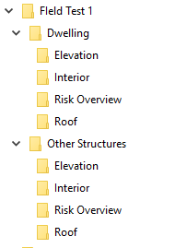

For example: Keystroke Combination

**Dwelling🡪Roof🡪Pitch🡪3/12**

will result in generating file name

**Roof Pitch 3~12.JPG**

And It will be stored in the folder PC or Mac



Roof Pitch 3-12.JPG

Connecting iPhone via USB to PC or Mac

1.Install iTunes for PC

https://www.apple.com/itunes/download

2. Type in your credentials (iTunes/apple ID and password)  
If connected to PC or Mac for the first time choose option trust this computer from your iPhone menu

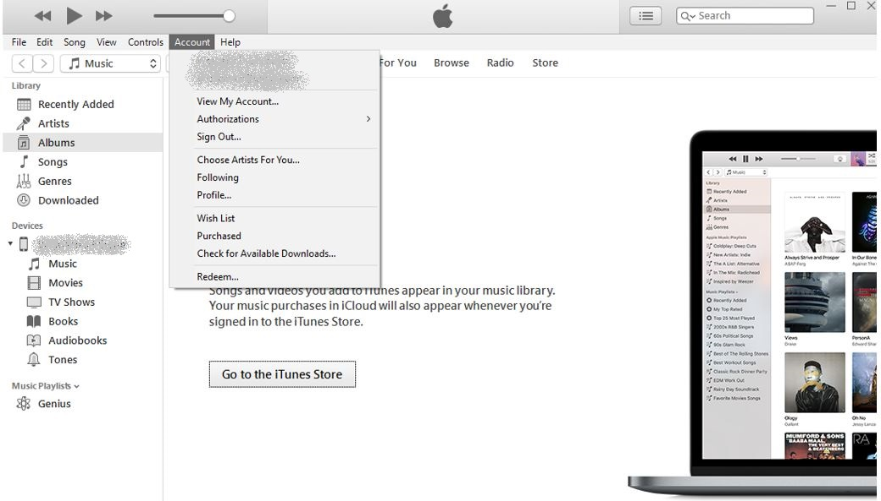

3. Connect your phone via USB Cable. Select your phone by clicking phone icon

If the phone icon does not appear, click the link below for trouble shooting

<https://www.youtube.com/watch?v=ovGSgEne1Zc&feature=youtu.be>

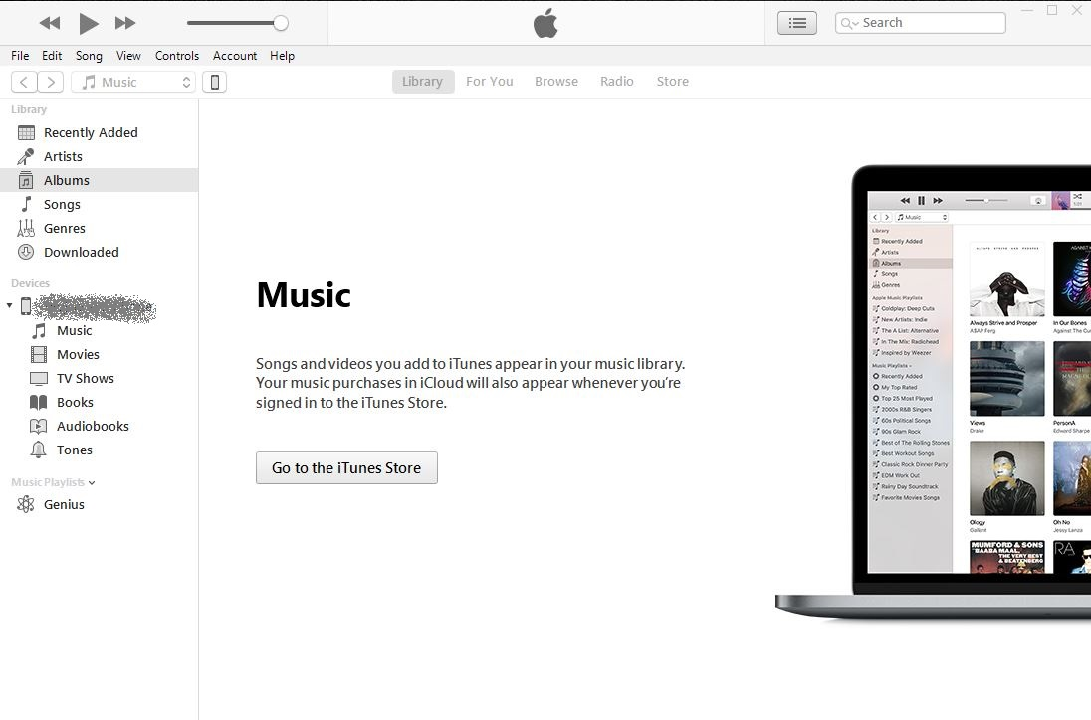

4. Choose option File Sharing. Click on application icon. Choose Project name from list. Save Project on Hard Drive

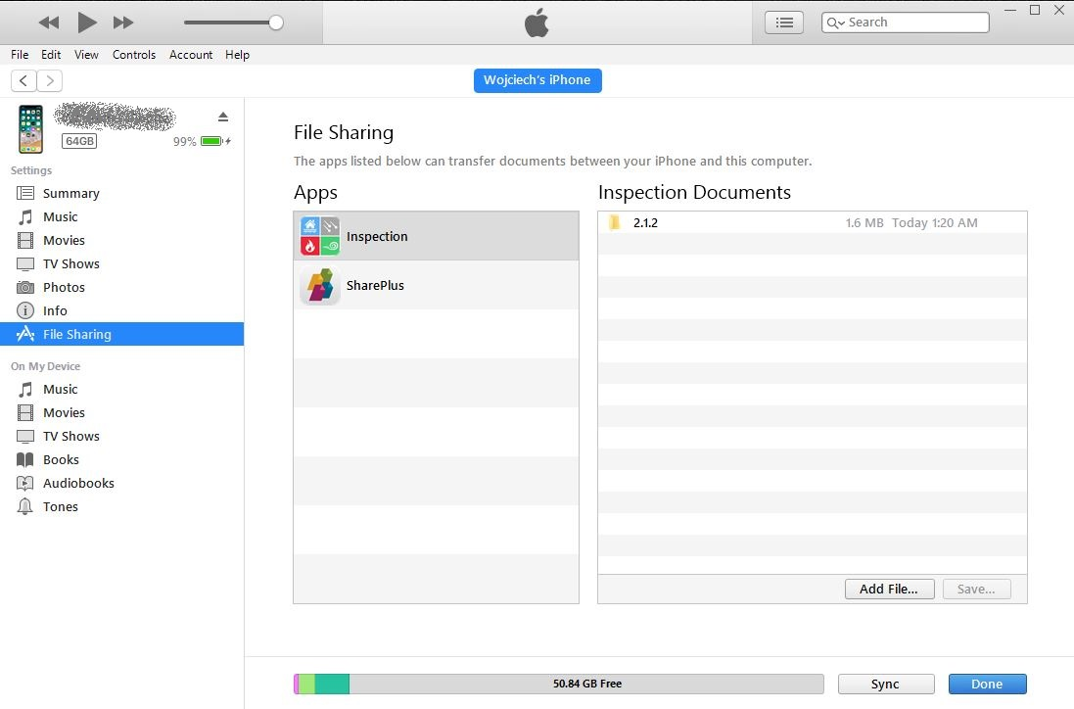

MyAdjustiMate

**Upload Files from Android to PC /** **Back to ToC**

1. Connect your phone via USB Cable. Go to This PC (or My Computer),

Phone will appear as a removable drive

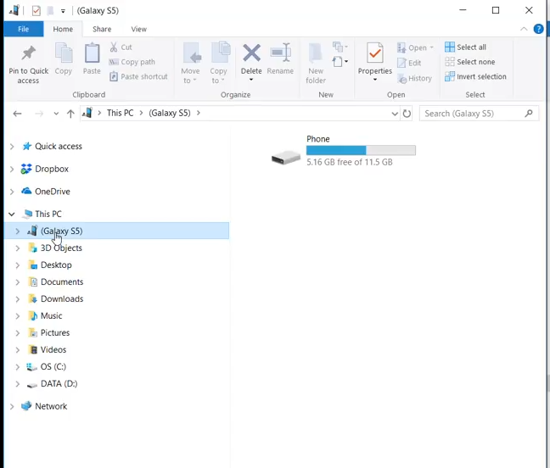

1. Follow the Path: This PC🡪Your Phone🡪 **Phone/Android/Data/com.myadjustimate/Your Project**

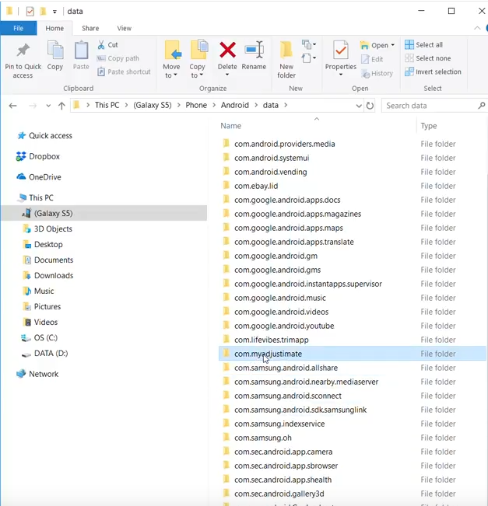

**Drag and Drop Photos to Xactimate /** **Back to ToC**

**Open Xactimate Photos Section Window**

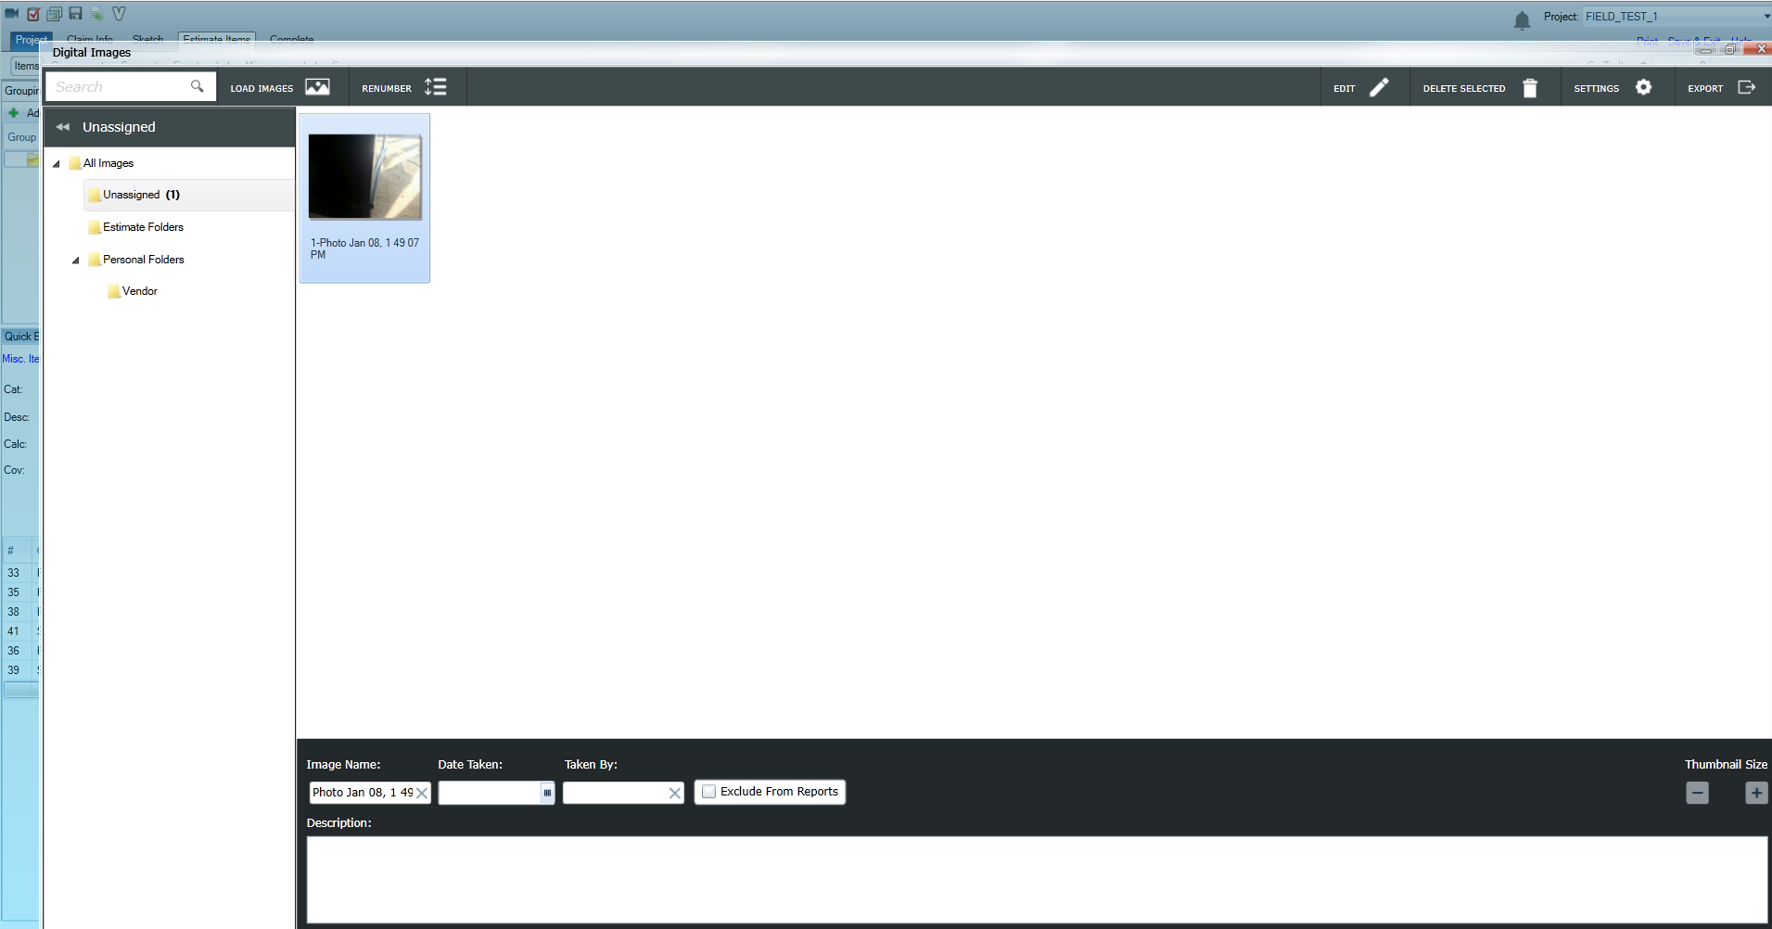

When typical image file (for example **“Photo Jan 08.jpg”** or any other generic format) is being drag and drop from photos folder to Xactimate Digital Images Window, by default it creates Image Name same as File Name

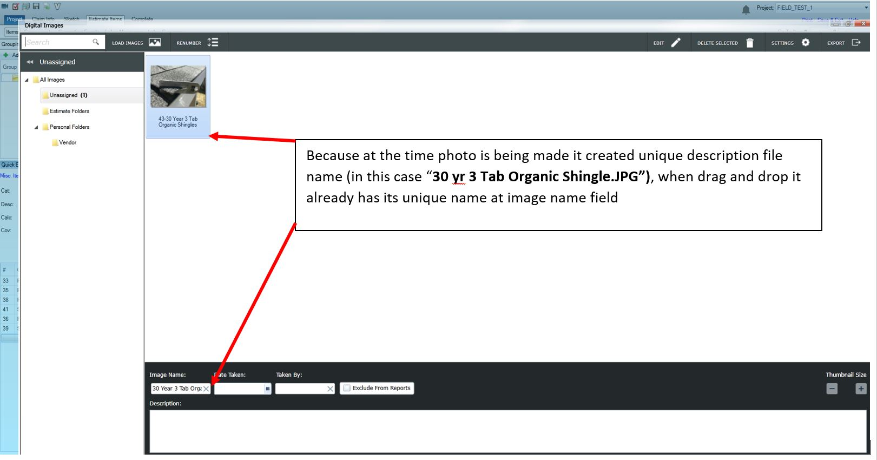

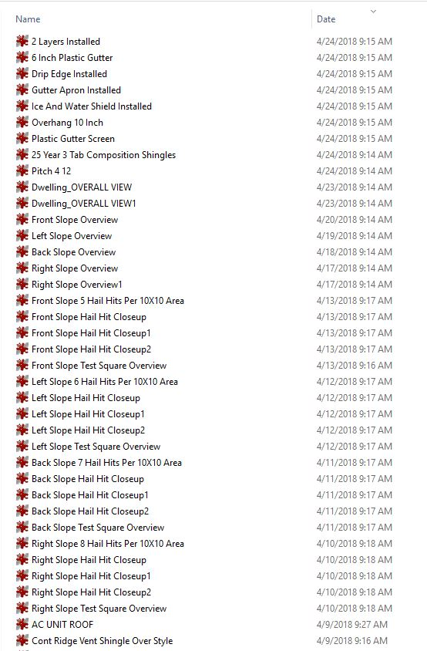

**Before Drag and Drop to Xactimate,**

**make sure you sort photos within the folder by Date (Ascending) as photos are given an unique priority tag**

**Photos sorted “By Date” receive the following priority level**

